**Background:**

I have made a treemap to show US Ethinc Group Population by state , and I have successfully implemented it in a separate html and js scritp, the product is the following treemap, top layer is total population by state

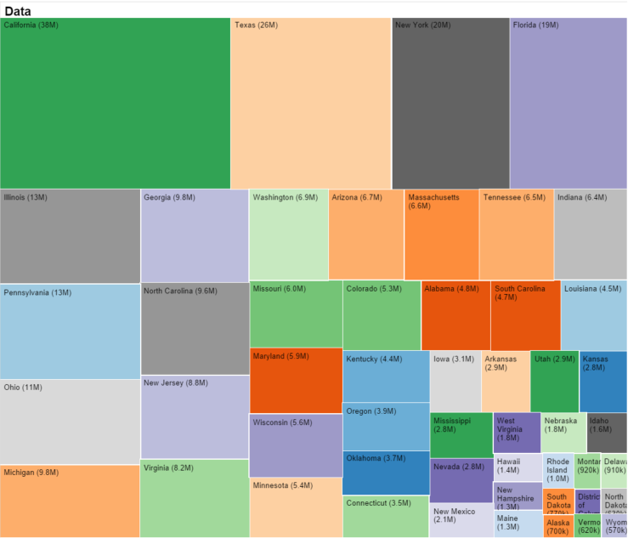

And if clicking any state, the vis changes to the 2nd layer, take California as example

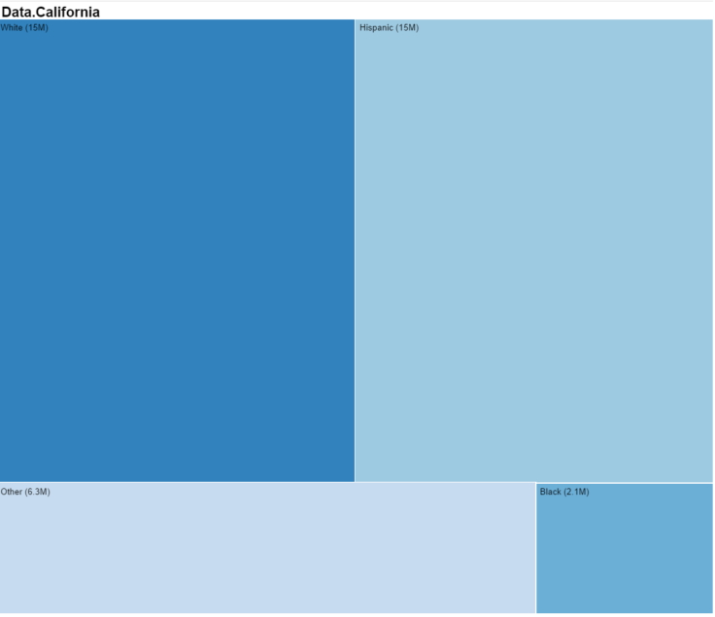

**Problem**

In this **completed working version** of treemap, have to use <http://d3js.org/d3.v2.js> as the refered library script which has related functions definition d3.layout.treemap() .

**Now I need to migrate this to a coordiante veiw** , and I use the hw3 coordinated view index.html as the template for my project, in hw3 we use libs/d3/d3.min.js( here I name it as d3.min_hw3.js to differentiate the one I modified which I will explain later), so I added the <http://d3js.org/d3.v2.js> library



And the visualization is NOT running at all in this case even for other non- treemap visulizations, however when I remove <http://d3js.org/d3.v2.js> library, other visulizations will show up but treemap. Therefore this is the conflict on appearance that I can’t have these two lib files at the same page.

**My solutions(** partially working only**)**

Since adding two libraries at the sametime will not run visulizations at all for some reason( the console showed no error), I tried to merge them into one library file namded d3.min.js.

I debugged through and found it is because without <http://d3js.org/d3.v2.js> library, d3.layout.treemap() can’t be recognized.

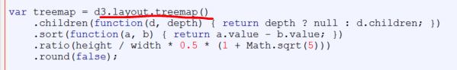

I first tried to copy paste all d3.v2.js into d3.min_hw.js, it does n’t work, and then I found I had to manually define d3.layout.treemap in the new d3.min.js like below, the first paragraph is the orignial hw3 d3.min.js file, and the second graph starts with d3.layout.treemap is the one I added.

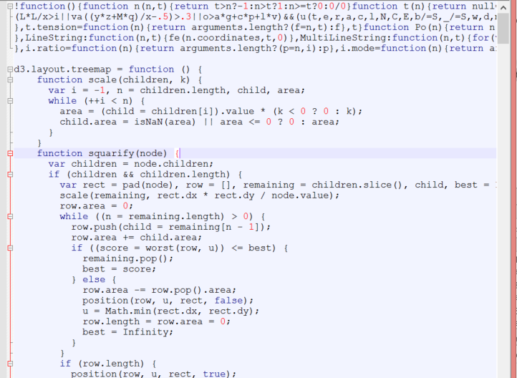

I ran it and it gave me other erros showing undefined functions, so I search in d3.v2.js and found the

related functions and keeping add them into d3.min.js like below

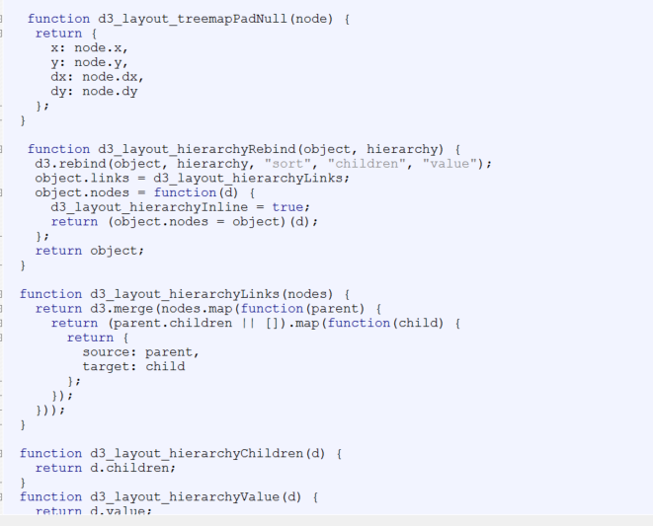

This step by step debug method and adding multiple functions from d3org. v2.js to d3.min.js , it

finally takes me to the place where I can show my treemap, see the modified d3.min.js library I used



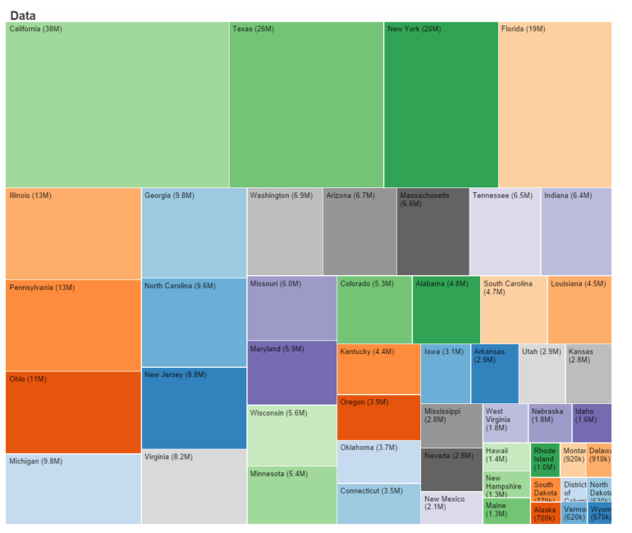

However this treemap can’t show the 2nd layer, I debugged again by comparing it with the working single treemap vis I made previously, the differences are the definitions of treemap.children

Complete working version , in the console, here is treemap.children, notice this function defintion is by d3.v2.js.

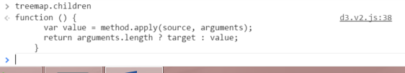

The 2nd layer non working version, in the console, here is treemap.children, notice this function defintion is by d3.min.js which is from hw3.

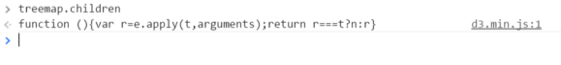

This is where the conflict I am struggling now, in sum, I have to use d3.min.js for coordinated view, but the orignial d3.min.js is not used in my treemap visulization and its first line overwrites the treemap.children definition which is different from the one defined in d3.v2.js, and adding both d3.v2.js and d3.min.js will not run any visulizations at all, and my solution of merging two js files only partially works.